Information Contact:
Robin Tindall, CFRE
Executive Director and CEO
Highlands Cashiers Health Foundation
348 South Fifth Street
P.O. Box 742
Highlands, NC 28741
828-482-6513

For Immediate release: January 31, 2020
HIGHLANDS CASHIERS HEALTH FOUNDATION APPROVES DISPERSAL OF $2.5 MILLION TO AREA NONPROFITS IN ITS 2019 FOUNDING YEAR
Highlands Cashiers Health Foundation Disperses $847,022 to Enhance Education Initiatives and Improve the Lives of Children on the Plateau and Surrounding Communities
Living up to its stated intention, Highlands Cashiers Health Foundation has approved nearly $2.5 million dollars to area charities since its founding February 1, 2019. The Foundation was reconstituted from the assets of the Highlands Cashiers Hospital Foundation when Mission Hospital, a non-profit organization was sold to Hospital Corporation of America, a for profit organization last year.
“When Mission sold the hospital to HCA last year,” said Dr. Walter Clark, chairman of the Foundation Board, “we had no alternative but to reorganize our Foundation since we could no longer use our funds to support a for profit hospital.” He continued that the Board decided, however, to continue long legacy of donor support of investment in health and vibrant communities.
Investments have been made in 53 organizations over the last year including programs and projects that focus on improving the health and wellbeing of Highlands, Cashiers and the surrounding communities in three areas: Health and Access to Healthcare, Youth and Education Initiatives, and Community Vitality.
The Highlands Cashiers Health Foundation (HCHF) committed $847,022 to 17 area organizations to support and enrich the lives of children and to enhance educational opportunities across the six-county region. The Foundation awarded grants spanning from placing nurses and social workers in K-12 and Early College Schools to technological improvements and upgrades in both the K-12 and University settings.
To meet the need for increased technology at Highlands School Highlands Cashiers Health Foundation funded a technology grant to Advance Highlands Education Committee (AHEC), “After polling our teachers at Highlands School, we realized that technology was a top need,” said Hilary Wilkes, President, Advance Highlands Education Committee. “Technology is an integral part of our children’s lives every day, and we also know that by using technology in our schools our students benefit by having increased engagement, improved knowledge retention, and can learn at their own pace. We are grateful to Highlands Cashiers Health Foundation for funding the purchase of ActivBoards and recognizing our efforts to improve technology and education for the students at Highlands School for years to come.”
While enhancing technology and similar educational improvements was a focus, the Foundation also supported several youth development organizations and programs. Highlands Cashiers Health Foundation funded youth development programs that not only prevent children and teens from participating in unhealthy behaviors but build their self-esteem and life competency skills.
One supported organization that is building our youth’s self-worth and life skills is HIGHTS, Inc. Marcus Metcalf, Executive Director, HIGHTS, INC. states "HIGHTS is grateful to partner with the Foundation to provide therapeutic crisis stabilization services for the most vulnerable youth in our community through our Inside Out Program, as they gain the life skills necessary to flourish and become contributing members in our society.” Metcalf continues, “HIGHTS understands that if we do not provide critical services to these youth now, then our community is going to pay for them exponentially throughout their lives through incarceration and addiction. "
Youth development programs are vital to the wellbeing of children; as is ensuring they have healthy home environments. HCHF provided grants to organizations in our region that support youth welfare such as Eliada’s Foster to Adoption Program. Eliada President/CEO states, “Eliada’s mission is Helping Children Succeed. With the support from the Highlands Cashiers Health Foundation, Eliada Home will grow their capacity to recruit, train, and license foster parents in Cherokee, Clay, Graham, Jackson, Macon, and Swain counties. With an increase in foster parents in these counties, when a child enters care, Eliada will be able to match them with a family near their home community, maintaining the child’s natural support system. Proximity to biological family also increases the likelihood of reunification with family when possible. Overall, keeping children close to their home community reduces trauma and increases the potential for permanency.”
In 2019, the Highlands Cashiers Health Foundation is proud to approve the dispersal of $2.5 Million dollars to 53 organizations. Through the journey of conducting Listening Sessions, Community Outreach Meetings, and committing over 2000 hours toward grant review, the Programs and Grants Committee and the Highlands Cashiers Health Foundation Board of Directors has learned so much about our community and the incredible strengths it possesses through existing nonprofits as well as the road blocks to health that are prevalent in our community.
“This year has been a landmark year for the Foundation; an outstanding year for progress and positive growth for our community. I am honored to serve alongside fellow Board Members and dedicated Community Advisors. We all look forward to continuing this momentum and building upon it to create lasting impact for generations to come.” Walter Clark, Chair of the Highlands Cashiers Health Foundation.
The Foundation looks forward to another tremendously impactful year in 2020, as it will be unveiling strategic priorities that will truly move the needle forward for Highlands, Cashiers, and the surrounding communities. “” says Robin Tindall, Executive Director and CEO of the Highlands Cashiers Health Foundation.
About the Highlands Cashiers Health Foundation
The Highlands Cashiers Health Foundation was established on February 1, 2019 as a 501 (c) 3 public charity with a purpose to improve the health and wellbeing of Highlands, Cashiers, and surrounding communities. As the Highlands-Cashiers Hospital conversion foundation we are committed to continuing a several-decade legacy of generosity and vision to ensure vibrant and healthy living for our year-round, seasonal and visiting families and individuals. Through partnerships with organizations, key stakeholders and caring donors, the Foundation aims to make positive and lasting change through investing in projects and programs that advance innovative solutions and improvements in peoples’ health and wellbeing. The Foundation also includes collaborative partnerships that serve the health and wellbeing of all people in western North Carolina, with particular emphasis on Macon, Jackson, Swain, Graham, Clay and Cherokee Counties and the Qualla Boundary. For more information please visit the website: www.hchealthfnd.org or call 828-482-6510.

Supporting Photos on Page 3; Funded Organizations on Page 4

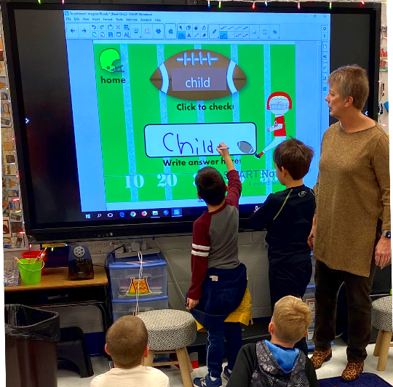
Photo Caption:
Teacher at Highlands School instructs students on a new ActivBoard installed after purchasing with funds from the Highlands Cashiers Health Foundation.

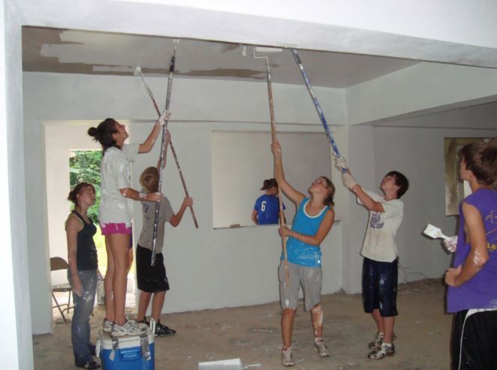
Photo Caption:
Teen participant’s in the Inside Out Program with HIGHTS, helping to build a home in Jackson County.

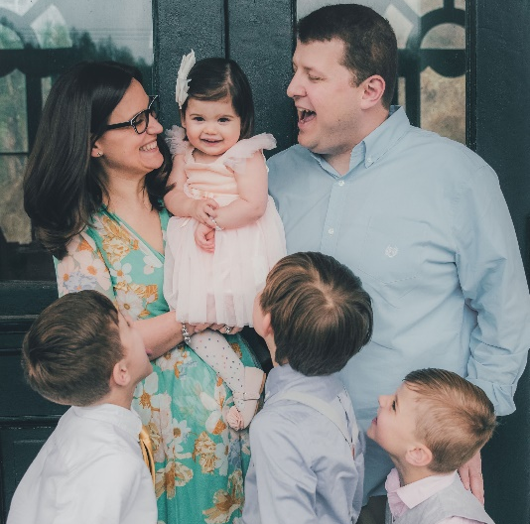
Photo Caption:
A FAMILY GROWS THROUGH AN ELIADA ADOPTION.

With the support of the Highlands Cashiers Foundation, Eliada Home will grow their capacity to recruit, train, and license foster parents in Cherokee, Clay, Graham, Jackson, Macon, and Swain counties.

Health and Healthcare: $1,024,124
Access to Healthcare: $817,064
- AWAKE, Inc.
- Blue Ridge Free Dental
Mental Health and Substance Abuse: $207,060
- Clay County Department of Social Services
- Counseling and Psychotherapy Center of Highlands
- Meridian Behavioral Health Services
- REACH of Macon County
- Swain County
- Warrior Survival School

- Cashiers Glenville Fire Department
- Clay County Governing Board
- Clay County Public Health Department
- Community Care Clinic of Franklin
- Community Care Clinic of Highlands
- Glenville-Cashiers Rescue Squad, Inc.
- Hospice House Foundation of WNC
- KIDS Place
- Macon County EMS
- Mountain Area Health Education Center
- Mountain Area Pro Bono Health Services
- Smoky Mountains Outreach Foundation
- Southwestern Community College
- Vecino’s Farmworker Health Program
Education and Youth Initiatives: $847,022
Youth Development: $244,022
- Boys and Girls Club of the Plateau
- Cashiers Big Brothers Big Sisters
- Eliada Homes, Inc.
- Highlands-Cashiers Land Trust
- HIGHTS, Inc.
- The Bascom
- The Still Place

Education: $603,000
- Advance Highlands Education Committee
- Blue Ridge School Education Foundation
- Cashiers Valley Preschool
- Clay County Board of Education
- Hampton Preschool and Early Learning Center
- Highlands Community Child Development Center
- Southwestern Child Development Commission
- Summit Charter School
- The Literacy Council
- Western Region Education Service Alliance

Community Vitality and Economic Stability: $513,000
Combatting Food Insecurity: $198,000
- Clay County Food Pantry
- Fishes and Loaves
- The Community Table
Community Enrichment: $55,000
- Peggy Crosby Center
- Vision Cashiers

Poverty Reduction: $260,000
- Circles Cashiers-Glenville
- HERE in Jackson County, Inc.
- Life Challenge of WNC
- Mountain Projects, Inc.
- Pisgah Legal Services
- Restoration House WNC
- International Friendship Center
- Macon County Care Network
- MANNA Food Bank

